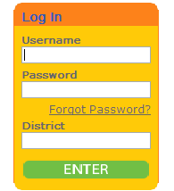
Learning.com/ EasyTech
Logging in and finding curriculum activities

- Go to Learning.com. Use your Novell login with the password you set up last year -Students login with their regular NOVELL login and use their LUNCH NUMBER as their password put eanes isd as the district
- Click on CURRICULUM 
- Click the grade level of interest under EASY SETS

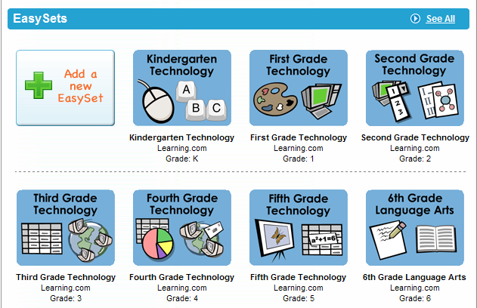
4. Choose topic (to fast forward a lesson video, SHIFT + ~ and click on the top left of the screen, now the scroll on the bottom right will be active.
- D=discussion L=lesson A=activity P=Practice or Drill Q=Quiz


Lessons to try:
Grade – user id/password

Kinder – techk/tech
- Select, drag and double-click
- Brushes and lines
- Shapes and fills

1st - tech1/tech
- Words Spaces Enter
- Cursor, Arrows, Tab
- Shift and Symbols

2nd - tech2/tech
- Formatting Text
- Creating Documents
- Grouping and Labeling

3rd – tech3/tech
- Idea Webs
- Formats and Outlining
- Visual Mapping Unit Quiz
4th – tech4/tech
- Parts of a Spreadsheet
- Tables and Data
- Cell Formatting

5th - tech5/tech
- Browsing and URLs
- Key Word Searches
- Sources and Ethics

Set Up Your Class and Assign Curriculum

Click on Class at the top of the page | 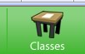
Click on Add a New Class on the left side | 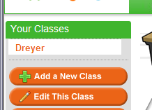
Give the class a name and choose your grade level. I recommend View Only for the Lesson Certificate. You must say YES for the student tracking to get a report. Your choice on the other two. They can be changed any time. | 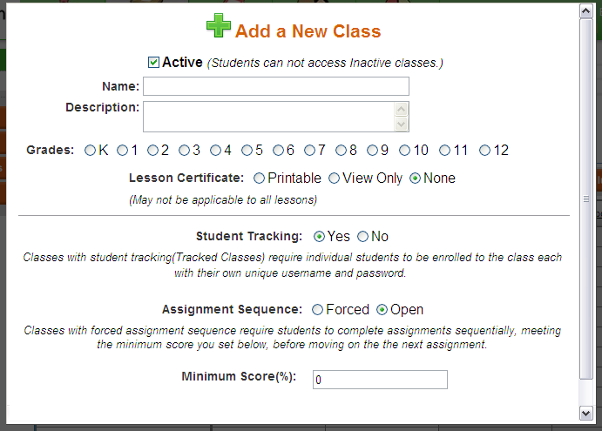
Choose Enroll Students and indicate the grade level. All students in that grade level appear and you can check you own and then enroll all. | 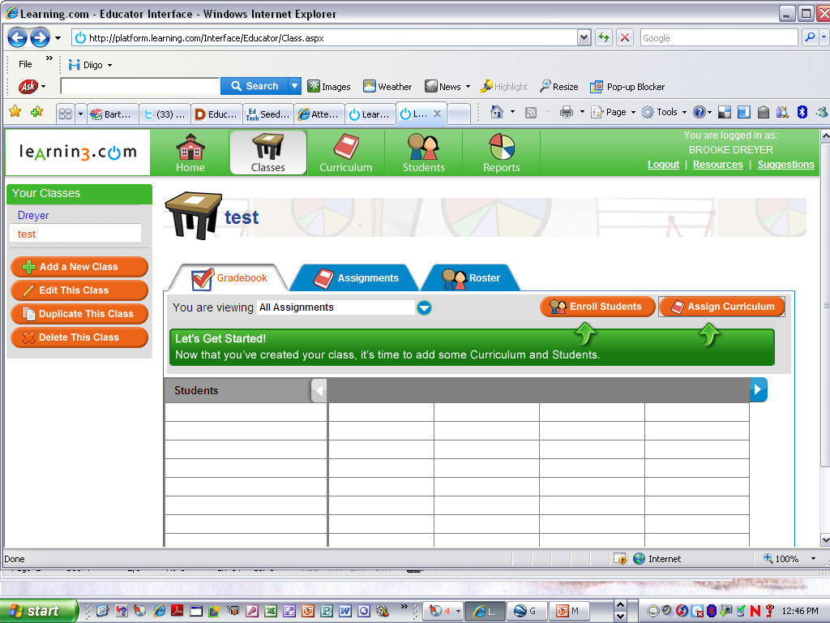
Assign Curriculum
You must have a class list before you can assign curriculum. Assignments can be made outside your grade level.

Printing a Report

Login and click on report at the top of the page. | 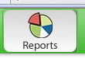
On the left side a list of reports will appear. Choose Gradebook | 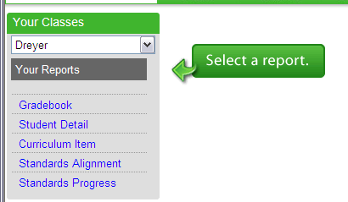
Click on Generate Report-Wait a little bit- Export as Excel (at the bottom of the pulldown list) | 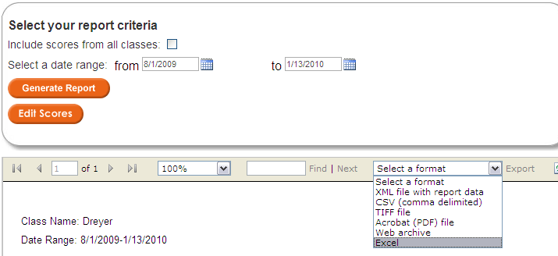

You can edit the Excel report if you want to or you can just print it as is.
(I would choose Landscape and see if I could print it on one page just to save paper.)

